
Product Dissection for Amazon

Company Overview

Amazon, founded by Jeff Bezos in 1994, is the world’s largest e-commerce and cloud computing platform. It revolutionized the retail industry by allowing consumers to shop for millions of products conveniently online. Amazon’s mission — “to be Earth’s most customer-centric company” — drives its innovations across logistics, AI-driven recommendations, Prime delivery, and third-party marketplace integration.

Product Dissection and Real-World Problems Solved by Amazon:

The home of online is the e-commerce behemoth Amazon, which has revolutionized retail around the world by solving real-world problems with digital tools. One of the challenges that Amazon is addressing is lack of product availability. Brick-and-mortar shops are limited by their geographic location and the size of their inventory, while Amazon is located online with an almost limitless number of products in many categories (books, electronics, music, clothes), which they can deliver to your door or pack in a truck.
Another crucial issue that Amazon solved is slow and unreliable deliveries. With its logistics breakthrough and “Amazon Prime” service, customers can have products delivered at a fast speed – sometimes even the same day. The company uses machine-learning algorithms and a large network of fulfillment centers around the world to maximize shipping routes and warehouse stocking.
Amazon also tries to address mistrust of online shopping. Features like verified customer reviews, seller ratings and transparent return policies help buyers make informed decisions and build user trust on an e-commerce platform.
The issue of information overload is effectively handled by their own AI recommendation, that utilized big data to tailor user experience and promote items likely to be of interest.
Finally, Amazon makes going to market accessible for small and medium businesses via its Marketplace platform. It provides a platform with global access and logistics support, which allows sellers to grow their businesses quickly. With these new dynamics, Amazon has not just changed consumer habits; it has also lit the way for others to follow in delivery of convenience, dependability and relevance in a digital economy.

Case Study: Real-World Problems and Amazon’s Innovative Approach

Case 1: Enhancing Customer Trust and Transparency
- Challenge: Customers hesitated to buy products without assurance of quality.
- Amazon’s Approach: Introduced verified purchase reviews, star ratings, and A-to-Z Guarantee protection.
  - The review system authenticates real buyers.
  - Seller metrics (on-time delivery, returns) are visible to buyers.
  - This data directly influences the schema via Review and SellerRating entities.

Case 2: Personalization at Scale
- Challenge: Customers faced decision paralysis due to the vast number of products.
- Amazon’s Approach: Machine learning-based recommendation engine.
  - Uses purchase history, browsing patterns, and ratings.
  - Schema connects User, Product, and OrderHistory entities for predictive modeling.

Case 3: Optimized Delivery and Inventory
- Challenge: Delayed deliveries during high-demand periods.
- Amazon’s Approach: Predictive logistics and distributed warehouse management (Fulfillment by Amazon - FBA).
  - The schema links Order, Warehouse, and Inventory entities to enable fast fulfillment tracking.

Schema Design Based on Top Features

1. User
Description:
The User entity represents every individual or business interacting with Amazon’s platform, including both buyers and sellers. It stores essential information such as personal details, contact information, and account type. This allows Amazon to differentiate between customers (who place orders) and sellers (who list and sell products).
Features Supported:
- Personalized shopping experience.
- Separate dashboards for buyers and sellers.
- Account management, order tracking, and security verification.
Attributes:
- UserID (PK): Unique identifier for each user.
- Name: Full name of the user.
- Email: Registered email for login and notifications.
- Address: Primary delivery or business address.
- AccountType: Defines whether the user is a customer or a seller.
- RegistrationDate: Date the user joined the platform.

2. Product
Description:
The Product entity captures information about all items listed on Amazon. It connects to sellers through the SellerID and contains details about each product’s characteristics, availability, and pricing.
Features Supported:
- Product listing and catalog management.
- Search and category-based browsing.
- Dynamic pricing and inventory tracking.
Attributes:
- ProductID (PK): Unique product identifier.
- SellerID (FK): References the seller who owns the product.
- ProductName: The product’s name or title.
- Category: Product classification (e.g., Electronics, Books).
- Description: Detailed information about the product.
- Price: The selling price of the item.
- StockQuantity: Number of available units in stock.

3. Order
Description:
The Order entity records purchase transactions made by users. It acts as a bridge between the user and the purchased products, maintaining order status, total cost, and timestamps.
Features Supported:
- Order placement and confirmation.
- Order tracking and delivery updates.
- Integration with payment and shipping modules.
Attributes:
- OrderID (PK): Unique identifier for each order.
- UserID (FK): References the customer placing the order.
- OrderDate: Date and time the order was placed.
- TotalAmount: Total cost of all items in the order.
- PaymentStatus: Indicates if the order is paid, pending, or failed.
- ShippingStatus: Tracks the shipment (e.g., Shipped, Delivered).

4. OrderItem
Description:
This entity stores detailed records of products within each order, allowing multiple products to be linked to one order. It captures item-level information such as quantity and price at purchase time.
Features Supported:
- Handling of multi-item orders.
- Calculation of subtotal per product.
- Seamless integration with product and order entities.
Attributes:
- OrderItemID (PK): Unique ID for each order item record.
- OrderID (FK): References the parent order.
- ProductID (FK): References the purchased product.
- Quantity: Number of units purchased.
- UnitPrice: Price per unit at the time of order.

5. Review
Description:
The Review entity captures customer feedback on purchased products. It helps maintain trust, transparency, and product quality through ratings and comments.
Features Supported:
- Verified buyer reviews and ratings.
- Seller performance tracking.
- Product ranking and recommendation input.
Attributes:
- ReviewID (PK): Unique identifier for each review.
- ProductID (FK): References the reviewed product.
- UserID (FK): References the reviewer (customer).
- Rating: Star rating from 1 to 5.
- Comment: Written feedback from the user.
- ReviewDate: Date when the review was submitted.

6. Payment
Description:
The Payment entity stores information about all payment transactions associated with orders. It ensures financial transparency and supports multiple payment methods.
Features Supported:
- Secure online transactions.
- Multi-method payments (credit card, UPI, wallet, etc.).
- Payment tracking and refund management.
Attributes:
- PaymentID (PK): Unique identifier for the transaction.
- OrderID (FK): References the corresponding order.
- PaymentMethod: Method used for payment.
- PaymentDate: Date and time of transaction.
- Amount: Total amount paid.
- TransactionStatus: Indicates success, failure, or pending.

7. Warehouse
Description:
The Warehouse entity represents Amazon’s physical storage centers. It manages stock distribution and regional availability to ensure efficient order fulfillment.
Features Supported:
- Real-time logistics and inventory management.
- Fast order processing through regional centers.
- Warehouse-level tracking and optimization.
Attributes:
- WarehouseID (PK): Unique ID for each warehouse.
- Location: Geographical location of the warehouse.
- ManagerName: Warehouse supervisor or manager responsible.

8. Inventory
Description:
The Inventory entity tracks product quantities across different warehouses. It ensures that stock levels are updated in real time and linked to product availability on the website.
Features Supported:
- Real-time stock management.
- Automatic restocking alerts.
- Warehouse-based product availability tracking.
Attributes:
- InventoryID (PK): Unique identifier for inventory record.
- WarehouseID (FK): References the warehouse holding the stock.
- ProductID (FK): References the specific product.
- QuantityAvailable: Number of items currently in stock.

9. Recommendation
Description:
The Recommendation entity supports Amazon’s AI-driven personalization system. It stores suggested products for users based on browsing history, previous orders, and ratings.
Features Supported:
- Personalized product suggestions.
- Cross-selling and upselling.
- Enhanced customer engagement and retention.
Attributes:
- RecommendationID (PK): Unique ID for each recommendation record.
- UserID (FK): References the user receiving the recommendation.
- ProductID (FK): References the suggested product.
- RecommendationScore: Confidence score of the recommendation based on relevance.

Rationale Behind the Design

The architecture in place for Amazon is carefully planned enabling scalability to be performed efficiently, and users are presented with a great user experience throughout this large e-commerce empire. At a basic level, the User entity is at the epicenter of both customers and clients having personal accounts. This is so that Amazon can differentiate buyers from sellers, but also maintain ultimate authority over interactions, transactions and reviews.

The Process, Product, Order and Payment processes underlie the business operation and manage keeping track of actual sales, order supply, secure monetary transfers. The OrderItem entity enables us to model multi-product orders, similar to how Amazon’s cart lets you purchase varied items in one go.

Apps like Review and Recommendation help boosting customer relations and trust. Reviews add particular transparency and allow informed decisions, whereas recommendations provision machine learning for personalized shopping experiences.

Warehouse and Inventory are in place to support its logistics backbone taking care of astate-of-the-art Stock management system and Real-time order processing. This allows Amazon to process lots of volume effectively while shortening delivery times.

The design embraces a modular and relational approach that comports with Amazon’s value of reliability, personalization and operational excellence. They all help preserve the trust that we and our customers have in Amazon and improves the performance of Amazon's supply chain.

ER Diagram (Entity-Relationship Model)

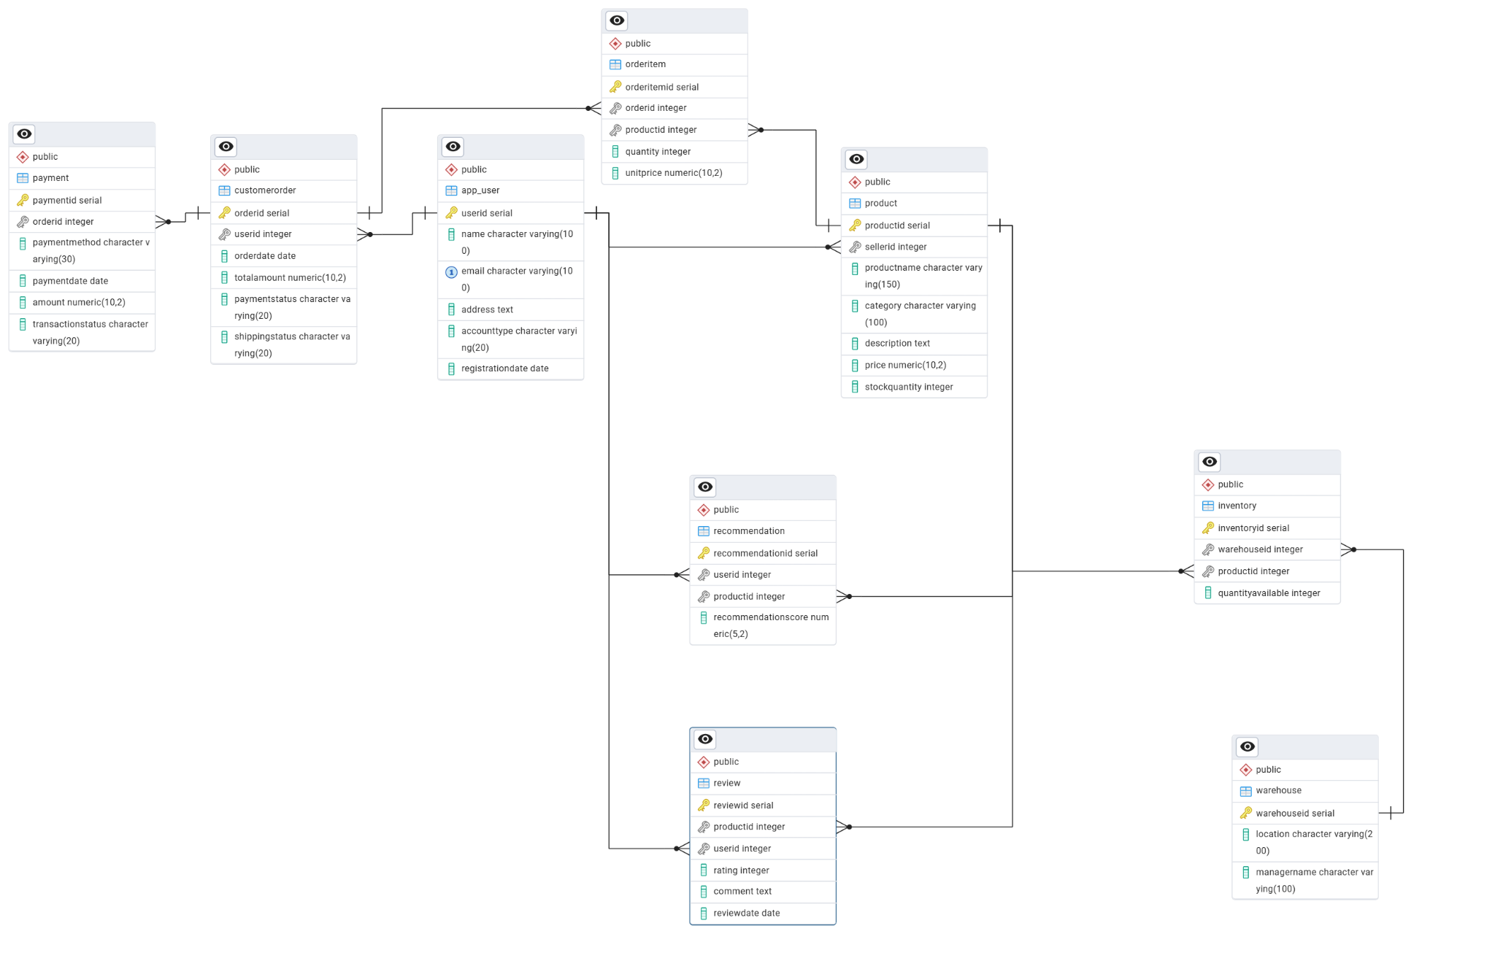

Conclusion
This product analysis reveals how Amazon’s schema structure is the foundation of its global dominance. By modeling users, products, transactions and logistics together all the way through mission completion, Shopify's model shows how intelligent schema design can help solve real-world problems — where trust is everything in online e-commerce and hyper-personalized experiences are a must.

Video Link

